When data travels across a network, it is encapsulated into a frame at the Data Link Layer (Layer 2). A frame has three main parts:
Ethernet Frame Structure :
+-----------+----------------+-----------+
| Header | Payload | Trailer |
+-----------+----------------+-----------+
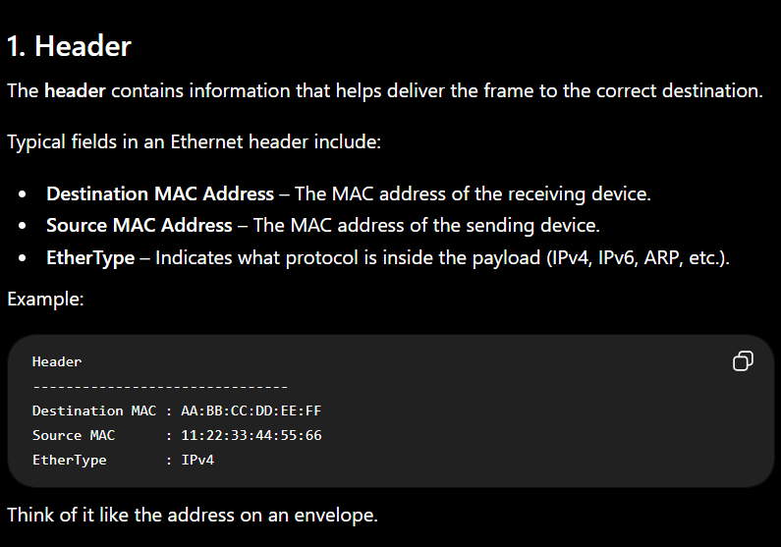

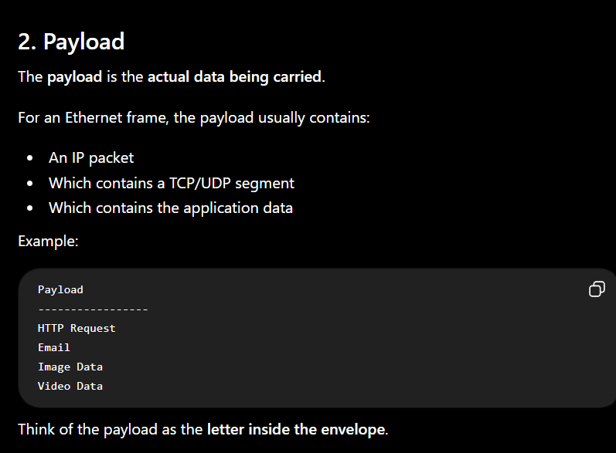
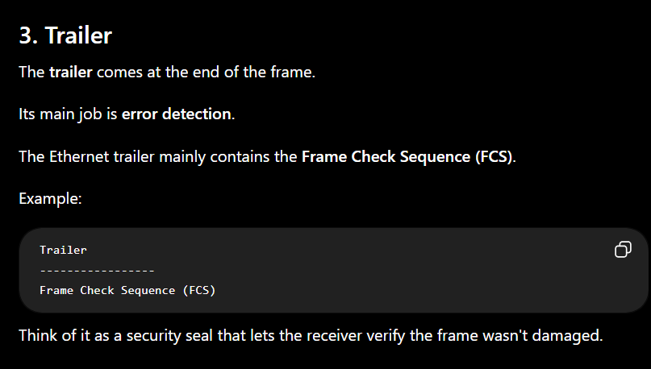

What is FCS?
FCS (Frame Check Sequence) is a 32-bit value placed at the end of an Ethernet frame.
It is used to detect transmission errors.
It is calculated using a mathematical algorithm called CRC (Cyclic Redundancy Check).

How FCS Works

Step 1: Sender
The sender:
- Builds the frame.
- Runs the CRC algorithm on the frame.
- Produces a 32-bit FCS value.
- Appends the FCS to the end of the frame.
Header | Payload | FCS

Step 2: Receiver
When the receiver gets the frame:
- It runs the same CRC calculation.
- It compares its calculated result with the received FCS.
If they match:
Calculated FCS = Received FCS
✔️ The frame is accepted.
If they do not match:
Calculated FCS ≠ Received FCS
❌ The frame is considered corrupted and is discarded.

Example
Suppose the sender sends:
Header
Payload = "Hello"
FCS = A1B2C3D4
During transmission, electrical noise changes the payload:
Header
Payload = "Hella"
FCS = A1B2C3D4
The receiver recalculates the CRC for "Hella" and gets a different FCS.
Since the values don't match:
- The receiver knows the frame was corrupted.
- The frame is discarded.

Important Notes
- FCS only detects errors; it does not correct them.
- If a frame is corrupted, higher-layer protocols (such as TCP) may request retransmission.
- Ethernet uses a 32-bit CRC, which is very effective at detecting accidental transmission errors.

Summary Table
Part | Purpose | Contains
Header | Identifies sender, receiver, and protocol | Source MAC, Destination MAC, EtherType
Payload | Carries the actual data | IP packet (and higher-layer data)
Trailer | Checks for transmission errors | Frame Check Sequence (FCS)

Exam definitions
- Header: Contains control information such as the source and destination MAC addresses and the protocol type.
- Payload: The actual data being transmitted.
- Trailer: The final part of the frame that contains the Frame Check Sequence (FCS) for error detection.
- FCS: A 32-bit value generated using Cyclic Redundancy Check (CRC) that allows the receiver to detect whether the frame was corrupted during transmission.

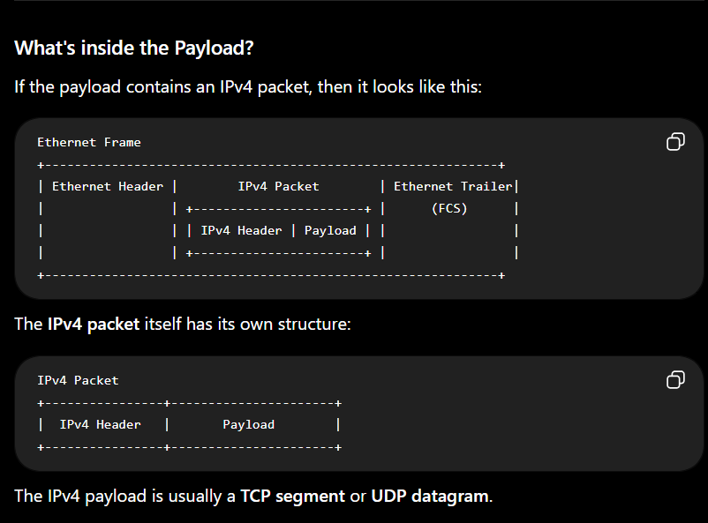
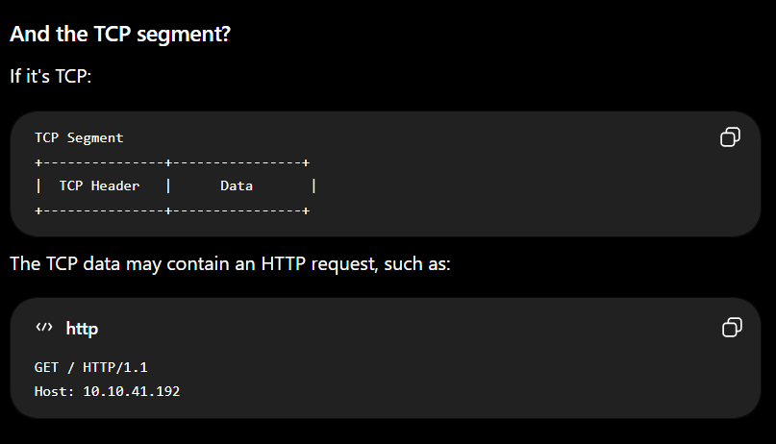

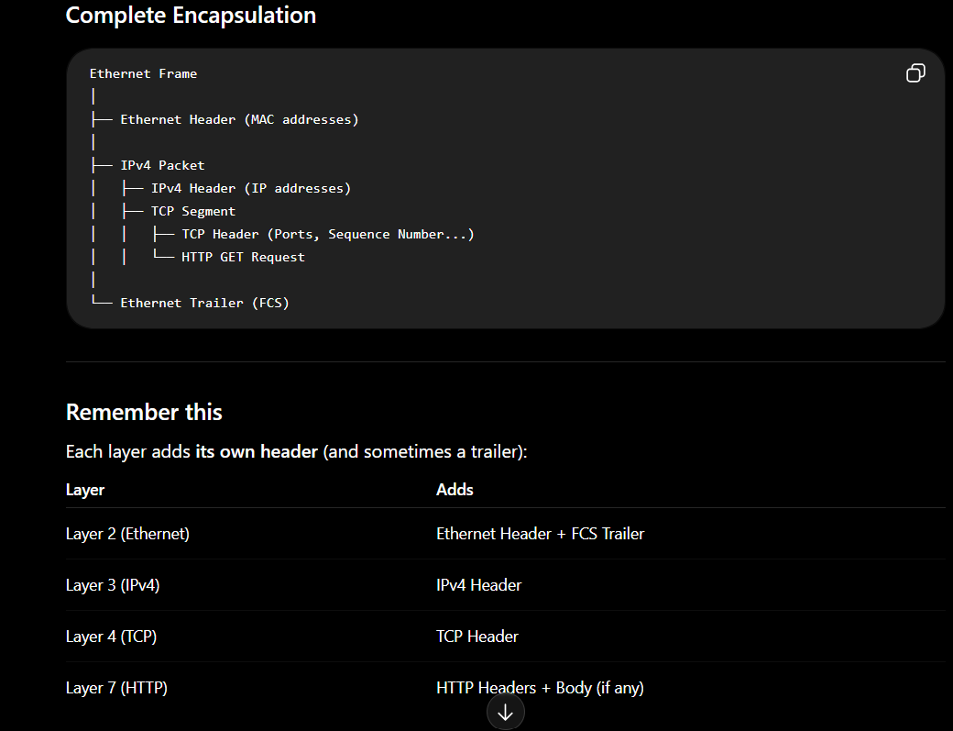

So, the "Header" in the original frame diagram is the Ethernet header, not the IPv4 header. The IPv4 header is inside the payload of the Ethernet frame. This is the idea of encapsulation: each lower layer wraps the data from the layer above with its own protocol information.

